# CS 255 System Design Document Template

## UML Diagrams

### UML Use Case Diagram

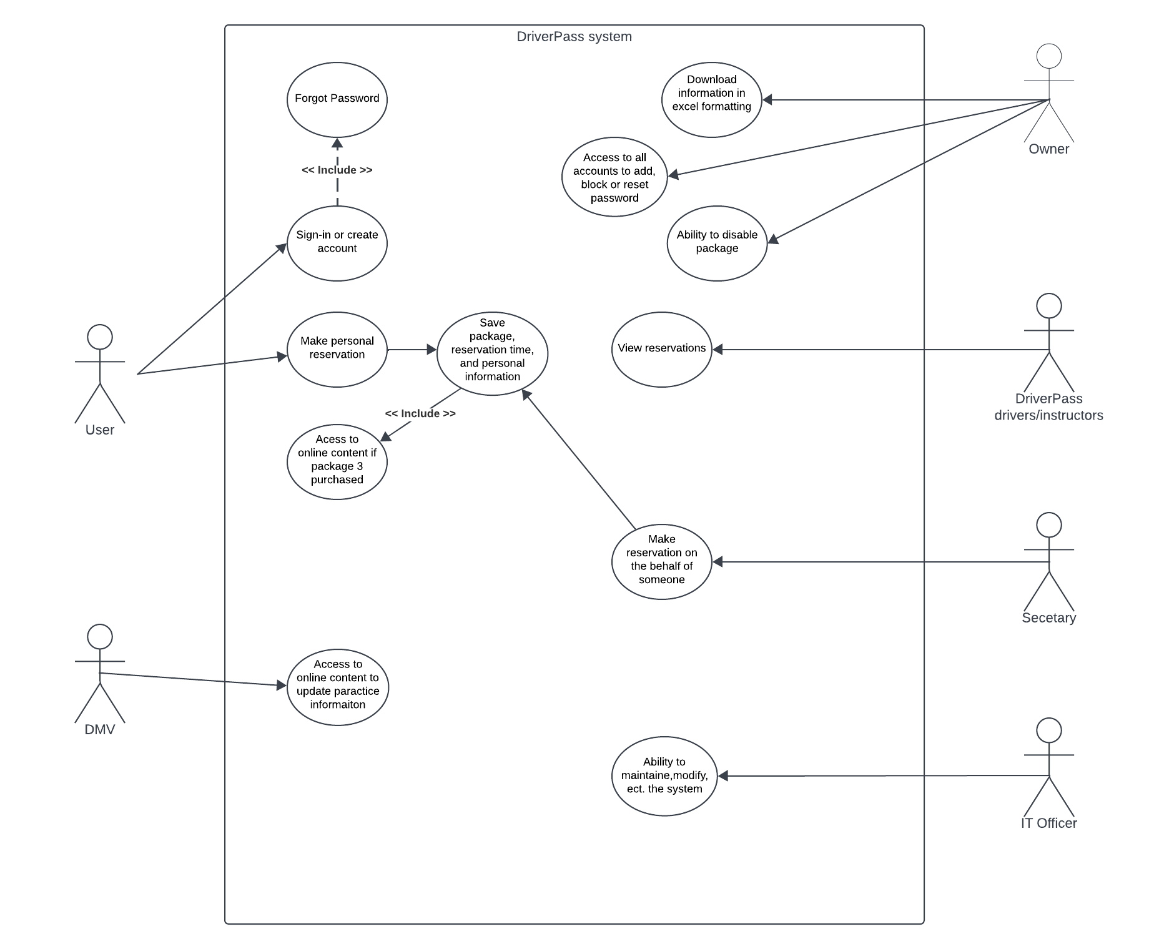

### UML Activity Diagrams

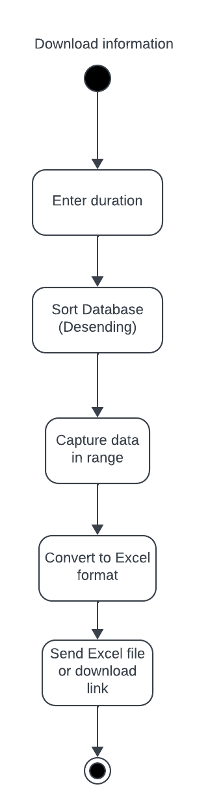  
  
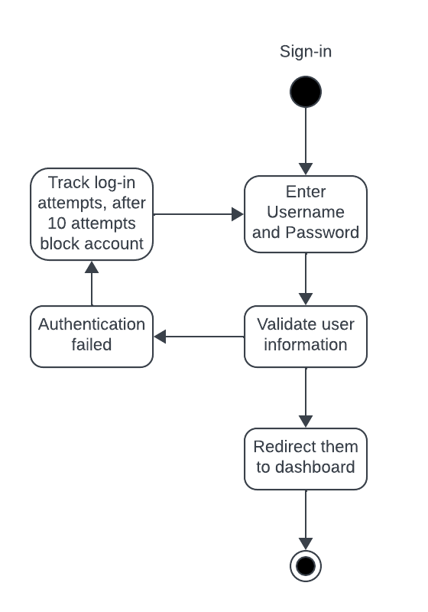

### UML Sequence Diagram

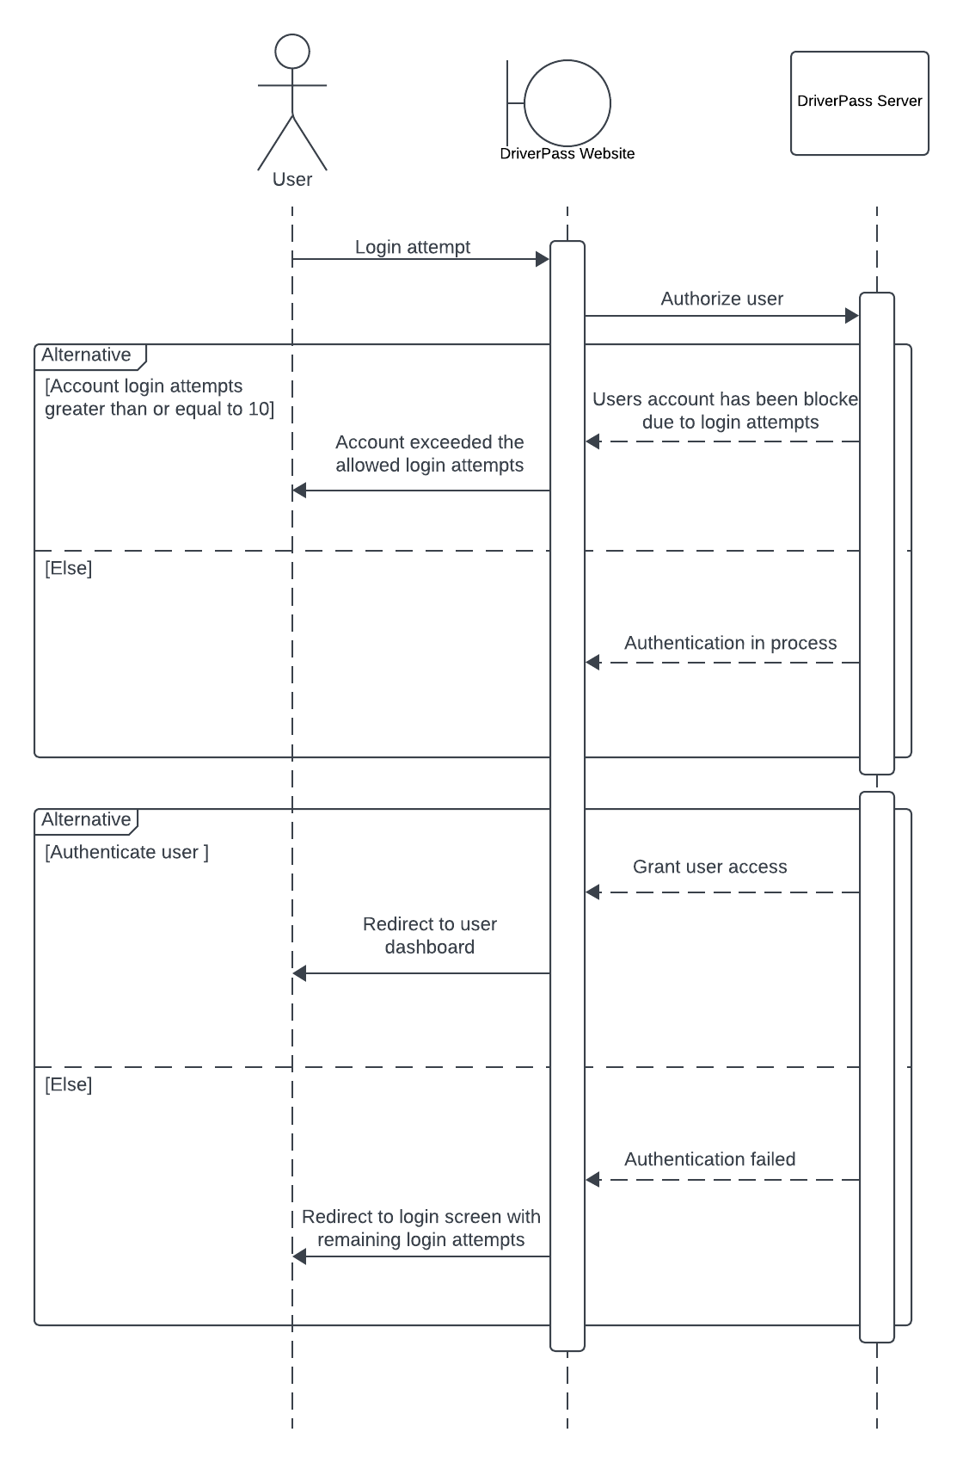

### UML Class Diagram

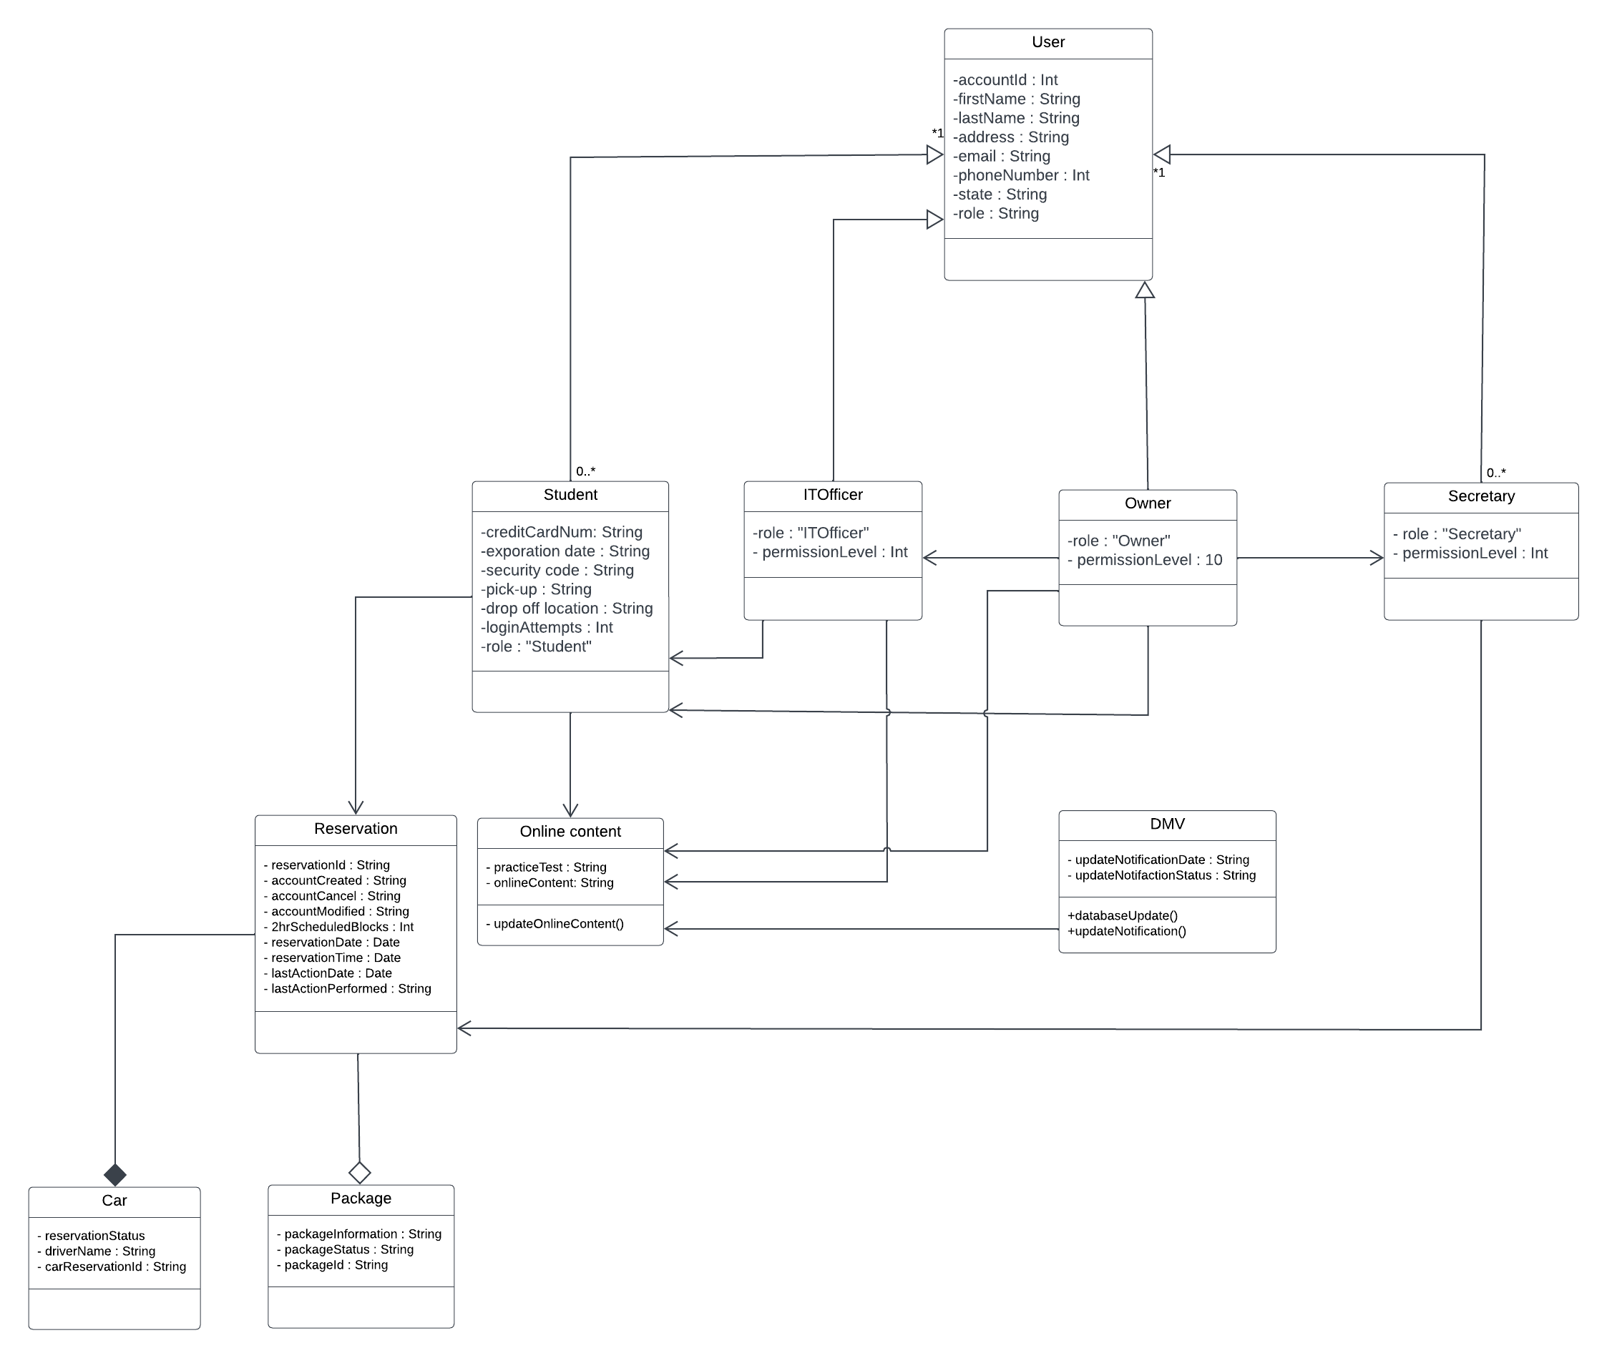

## Technical Requirements

*-DriverPass requested the system be cloud base.*

*-Cloud base server will need to be able to convert code to all operating systems in use.*

*-Will need to verify system can convert information into excel formatting.*

*-DriverPass will need to determine their desired payment service.*

*-Hardware requirements will be low due to being cloud base, will need a internet connection and internet capable device.*